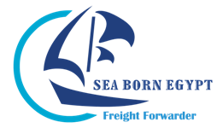

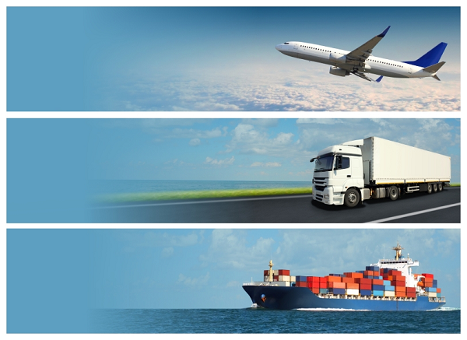

SEA BORN EGYPT is a privately owned freight forwarding company specialised in the fields of shipping and air transportation.
We are one of the best in the field working in the trucking and transportation of containers, general cargo, heavy and oversized equipments.
In addition, working in the field of foreign trade, importing of construction materials used in the infrastructure of some of the major projects in Egypt.

VISSION incorporated with years-of-experience experts in logistics field, we commit to bring our customers with best and most stable professional services.

MISSION is to provide safe, efficient services to Customers. And we encourage every member of our professional team to do his or her best to meet our customers’ expectations and fulfill their requirements.

Company Activities

- Sea Freight (for both FCL & LCL)
- Air Freight
- Door to door container transportation
- Trucking & Customs clearance
- Logistics solutions
- Documentations
- Other services required by customer

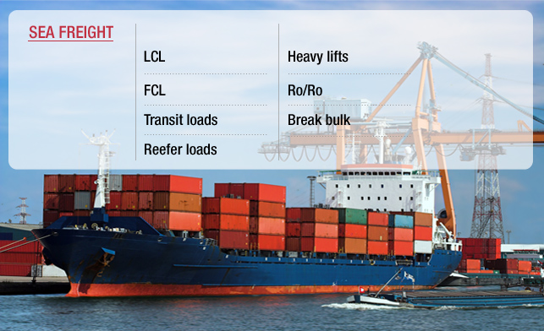

- Sea Freight (for both FCL & LCL)
- Handling vessels of all sizes in all Egyptian ports with utmost speed and efficiency
- Comprehensive disbursement account and cost control of all vessel's movement.
- Containers management and feeder’s operator.
- Suez Canal Transits minimization and accurate estimation of Canal tolls.
- Vessel's supply, bunkering and sign in/off of vessel's crew.

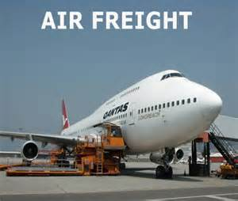

- Air Freight
- Efficient booking on all major airlines at all times.
- 24 hour services for export traffic & handling of regular / perishable cargos.
- 24 hour services for import cargo delivery to all cities in Egypt.

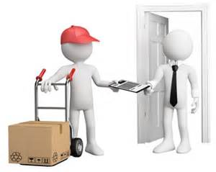

- Door to door

- Port-to-door and door-to-door service from shipper to consignee.

- Integrated service includes carton labeling, freight transportation and package delivery services.
- Streamlines processes by eliminating issues with multiple carrier bills.

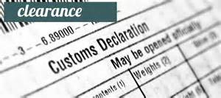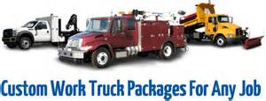

- Trucking & Customs clearance
- Having our own trucks.
- Avoiding usual delay by sub-containers or truck dealers.
- Licensed customs broker in house customs brokers serving in all major airports & harbors.
- 24 hour service for clearing both sea and air export shipments.
- Pre-cleaning approvals, drawback, temporary import, free zone and transit custom clearance for all import shipment regardless of commodity.
- Free customs consulting, traffic and commodity interpretation.

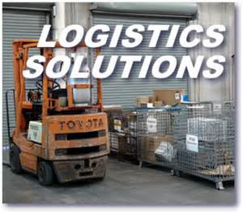

- Logistics Solutions

- Logistic solution (LSI) primary focus is of providing innovative business aligned solutions, by leveraging its deep business technology expertise.
- Experience in providing Quality IT Services.
- Comprehensive portfolio of offerings.
- Software development experts and support professionals.
- Specialized expertise to plan, design and build solutions based on various technologies.

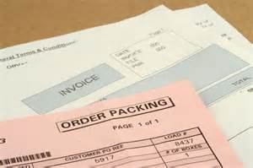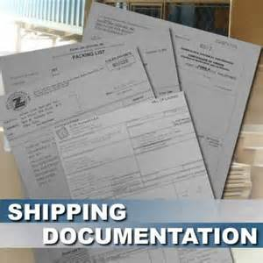

- Documentations
- Recovering of letters of Guarantee for draw back shipments.
- Recovering fund of ministry of Foreign Affairs on Egyptian exports.
- Issuance of Insurance Policies.
- Invoice visa for textile shipments to U.S.A.
- Export license for textile shipments to Europe.
- Export Register Card for non specialized exporters.

Why you should work with SEA BORN EGYPT?
SEA BORN EGYPT offer many advantages, services and facilities to our customers.
We will spare some of our advantages as following:

- AGENTS
Contact over 120 Agency All over the World to provide us suitable Quotation and to have the opportunity to compare the market rates with local lines.
- DANGEROUS CARGO&LIQUIDS
- Professional handling of dangerous chemicals and liquids.
- Tanker trucks for all kinds of liquids.

- ORDER RATE REQUEST ONLINE
Another service we are unique to present for our valued customers order you rate request online and we will reply within 24h

Address: 8 AL Farana st, AL Shalalat, Alexandria, Egypt
Phone: +2 03 48 59 393 / 4 / 5
Fax: +2 03 48 59 393 EXT (116)
Website: https://www.seabornegypt.com
E-mail: info@seabornegypt.com
Skype: sea.born.egypt
Face book: https://www.facebook.com/seabornegypt
LinkedIn: https://www.linkedin.com/company/sea-born-egypt
